CHAPTER 4
DATA COLLECTION AND SAMPLING METHODS

SECTION EXERCISES
4.1 d/p/e Primary data are generated by the researcher for the purpose of studying the problem at hand; secondary data already exist and are not generated for the sole purpose of studying the problem at hand. Internal secondary data come from sources within the company or industry being studied; sources such as accounting and financial statements and annual reports are examples of internal secondary data. External secondary data are compiled from sources outside the company or industry being studied.

4.2 d/p/m These data would be considered secondary data because the information was not generated by the researcher for the purpose of examining the problem at hand. Rather, the data are being saved to refer to in future studies.

4.3 d/p/m
a. These data would be secondary to the firm itself because the information was not generated to examine a specific problem.
b. These data would also be secondary to a competitor. Again, the data were not generated by the competitor to examine a specific problem.

4.4 d/p/m
a. These are primary data because Bertram is generating the data for the purpose of examining the problem at hand.
b. These are secondary data because Bertram does not generate them himself.
c. These data are also secondary because Bertram does not generate them himself.

4.5 d/p/m There are three major approaches to carrying out survey research: direct mail, personal interview, and telephone interview.

4.6 d/p/m There are, of course, many examples that would exceed the vocabulary level of the typical adult. Here are two likely possibilities:
"Do you derive positive utility from engaging in aquatic activities?" (Do you like water sports?)
"Should one engaging in geophagistic activities face extreme penalties?" (What is a geophagistic activity?)

4.7 d/p/m This question is biased and will most likely lead to many false negative answers.

4.8 d/p/m Random digit dialing is a technique used for telephone interviews. At least the last four digits of a phone number are randomly selected. This method has been developed to overcome the problem (and bias) of unlisted phone numbers in telephone surveys.

4.9 d/p/m A compiled mailing list consists of persons who are alike in some way, such as gender, occupation, or age. A response mailing list, on the other hand, includes persons who share some activity such as subscribing to the same magazine or making donations to the same political party.

4.10 d/p/m Sampling error is error due to surveying a sample rather than taking a census of the entire population. Response error is error due to respondents reporting information that is not truthful, and nonresponse error is error due to differences between those who responded to the survey and those who did not respond.

4.11 d/p/m This phenomonon represents a type of response error.

4.12 d/p/m If a nonprofit organization or university were to include a $20 bill as a monetary incentive for completing the questionnaire, this could exert a bias on the responses received. This relatively large monetary incentive might tend to reduce the respondent’s respect for the organization and to think that they are not really very much in need of the contributions and voluntary assistance such organizations often solicit.

4.13 d/p/m They would not want to employ the telephone survey method, as this would prevent respondents from actually being able to see and touch the alternative personal digital assistant models.

4.14 d/p/m
a. The dependent variable is wearing a seat belt, the independent variable is giving away lottery tickets.
b. There is no control group in this experiment, because everyone is exposed to the treatment.

4.15 d/p/m
a. The dependent variable is the rate of response; the independent variable is the monetary incentive.
b. The control group in this experiment is the group that does not receive the monetary incentive for responding to the survey. (They are not exposed to the treatment.)

4.16 d/p/m Internal validity is the extent to which changes in the independent variable, in this case the consumption of fried foods, are actually responsible for changes measured in the dependent variable,
in this case death rates. In this problem, the relative ages of the members of the two groups are not mentioned. Certainly the expected life of an older man is shorter than that of a younger man, so it could be that the lower death rates can be traced to a difference in the age composition of the two groups.
Not knowing the ages of the men involved, it is not at clear whether the differences in the consumption of fried foods contributed to the differences in the death rates.

4.17 d/p/m Among others, the general cleanliness of the exterior, whether it is part of a national chain of reputable restaurants, and many other possibilities.

4.18 d/p/m Burglars would be watching for things like uncut grass, accumulated newspapers or mail, the same pattern of lighting at night, no cars in the driveway. Vacationing homeowners are wise to install time-activated light controls, have friends or neighbors cut the grass and pick up newspapers and mail.

4.19 d/p/e Secondary data are collected by someone other than the researcher, for purposes other than the problem or decision at hand. Internal secondary data were gathered by someone within the firm or organization. External secondary data were gathered by someone outside the firm or organization.

4.20 d/p/m Other possibilities include annual reports, production records, engineering studies, marketing reports, and sales call reports.

4.21 d/p/m Corporate news, product offerings, prices, and specifications are often available from a company’s Web site. The browser home pages that offer stock quotes also typically offer corporate information, assessments, and recent news articles pertaining to a company’s future prospects. The U.S. Bureau of the Census Web site ( http://www.census.gov ) is one of the most powerful starting points to external secondary information of all types. Search engines like google.com allow us to find details about practically anything within just a few seconds. We can also tap others’ expertise through monitoring and participating in internet message boards and interest group forums.

4.22 d/p/m The Census of Population provides detailed information on the U.S. population, including age, education, employment, and a broad range of other demographic characteristics.
The Census of Housing provides data on such variables as home ownership or rental, type of structure, number of residents, market value, heating source, and major appliances.

4.23 d/p/m The Encyclopedia of Associations identifies industry-related trade associations that collect and disseminate data that are related to their industry. It is also an excellent source for identifying private organizations having special interests that may be related to the researcher’s informational needs.

4.24 d/p/m Data mining is analogous to physically sifting through great quantities of ore in the search for gold. It utilizes information and techniques that range from descriptive statistics, cross-tabulations, regression and correlation, all the way to factor analysis, cluster analysis, and discriminant analysis,
for the purpose of uncovering patterns and discovering interrelationships within the data.

4.25 p/c/m Results will vary, of course, depending on the county in which a college or university is located. As an example, for the University of Pittsburgh, a portion of the Bureau of the Census page dealing with Allegeheny County, Pennsylvania is shown below:
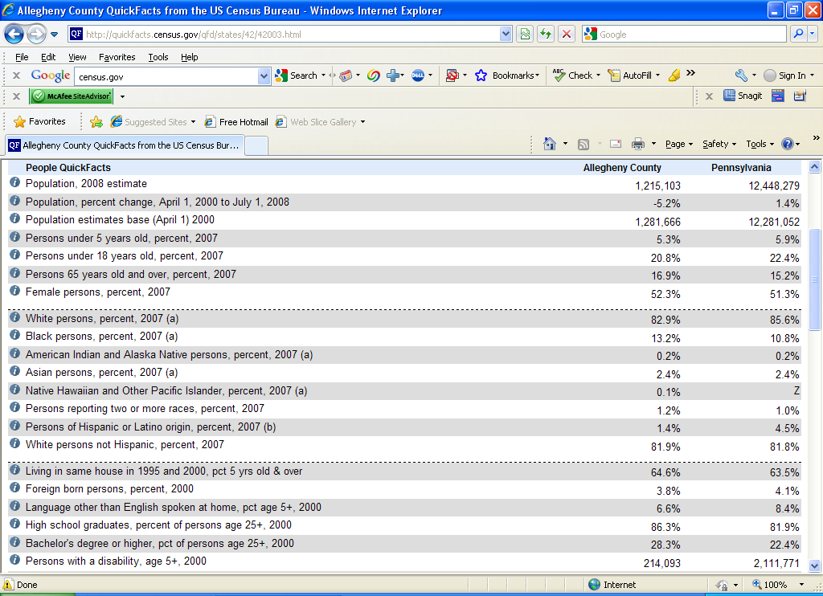
a. The median household income (not shown in the screen capture above) is reported as $46,402.
b. The Bureau of the Census reports that 16.9% of the 1,215,103 county residents are 65 years of age or older, but this page does not indicate the number of social security recipients. Another page within the site indicates that 29% of households receive social security benefits, and that the average amount received is $12,644 per year.
c. Per-capita retail sales (not shown on this screen) is reported as $11,469.

4.26 p/c/m A portion of the Bureau of the Census page for Dare County, North Carolina is shown below.
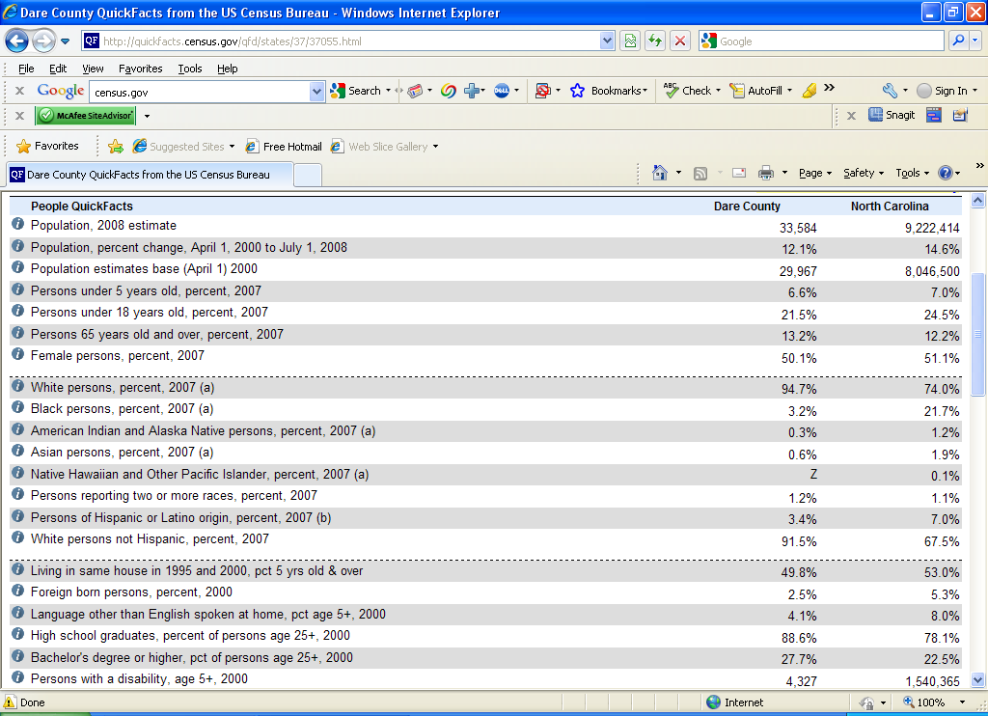
a. The median household income (not shown in the screen capture above) is reported as $35,258.
b. The Bureau of the Census reports that 13.2% of the 33,584 county residents are 65 years of age or older, but this page does not indicate the number of social security recipients. Another page within the site lists the number of social security recipients as 2435, with an average social security benefit of $11,500.
c. Per-capita retail sales (not shown on this screen) is reported as $21,699.

4.27 p/c/m Results will vary, depending on which company you view, and when. Shown below is a sample of McDonald’s Corporation information based on the company’s 2008 annual report, which can be downloaded in pdf format from the company’s website.
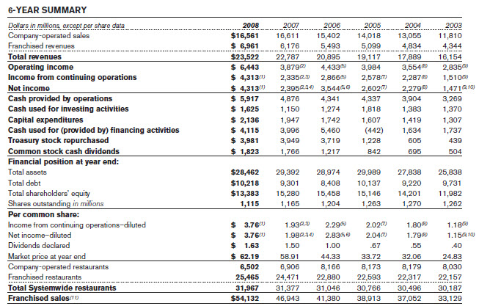

4.28 p/c/m
a. At this writing, ESPN.com’s message board contained 527,333 messages on 83,766 topics dealing
with the New York Yankees.
b. There are a number of national sites and many regional sites devoted to dart throwing and participants or enthusiasts. An example at the national level is the American Darters Association (adadarters.com). Dartlinks.com links to many national and international sites, and regional/local sites like the Pacific Darts Association (pacificdarts.com) and the Pittsburgh Dart Association (pghdarts.org) allow dart participants to communicate with their fellow enthusiasts.

4.29 p/c/m Depending on your last name, you might find either a very large number or just a few
listings. According to whitepages.com, even Pocatello, Idaho, has more than 100 “Smith” listings.

4.30 p/c/m According to petwebsite.com, the average lifespan of a Saint Bernard is 8 to 10 years.
A website identified as offering advice on how to write effective business letters and memos is write101.com/businessletter.

4.31 p/c/m This can be a real eye-opener. Suffice to say that there are a great many devices out there that most of us have never dreamed of. One of the many sites listed by Google is spyzone.com, and motion detectors, night vision equipment, covert cameras, tracking devices, and listening probes are only a few of the many devices offered for personal or industrial use.

4.32 d/p/e A sample is a selected portion of the elements within the population while a census is all possible elements from the population. It can be advantageous to select a sample instead of taking a census because a census can be extremely expensive and very time-consuming.
4.33 d/p/m A sampling error is an error that occurs because a sample has been taken instead of a census. It can be reduced by using a larger sample size. A nonsampling error is a bias because it is a directional error. Nonsampling errors cannot be reduced by simply increasing the size of the sample. It is necessary to take some action to eliminate the cause of the error.

4.34 d/p/m In order to find out how long their bulbs last, a lighting company has to use some of them until they no longer work. If every bulb were tested in this way, there would be none left to sell.

4.35 d/p/e A parameter is a characteristic of a population while a statistic is a characteristic of a sample. We typically use a statistic to estimate a parameter.

4.36 d/p/e This represents a nonsampling error since it is a bias or directional error that cannot be reduced by simply increasing the size of the sample.

4.37 d/p/e Nonsampling errors cannot be reduced by simply increasing the size of a sample. To reduce these kinds of errors, it is necessary to take some action that will eliminate the underlying source of the error, such as adjusting a machine or replacing parts that have become worn through repeated use.
In business research, nonsampling errors can arise from improper research methods or procedures, such as an interviewer whose personality causes respondents to provide answers that are biased in some way.

4.38 d/p/e This is a probability sample since each person who filled out a card has a chance of winning.
It is a a simple random sample since every person that filled out a card has an equal chance of winning.

4.39 d/p/m This is a systematic sample since we are selecting every k = 13th invoice.

4.40 d/p/m In a convenience sample, members are chosen mainly because of their availability and
willingness to participate. On the other hand, members of a judgment sample are selected because the researcher believes they are representative of the population regardless of availability.

4.41 d/p/d The quota sample and the stratified sample are similar in that the population is divided up into layers or "strata". However, in a stratified sample a simple random sample is taken of members from each stratum, while the members of the various strata are not chosen using a probability sampling technique in a quota sample. The quota sample is far inferior to the stratified sample in terms of representation.

4.42 d/p/m In a probability sample each element in the population has a chance of being included. However, everyone in the population does not have a chance of being included in a nonprobability sample. To statistically generalize from the sample to the population you need a probability sample.

4.43 d/p/m
a. The agent should use a sample so that relatively few of the watches will have to be broken.
b. The company should use a sample because it would be too difficult and expensive to find
every individual who consumes Cheerios.
c. The producers should use a sample because a census would take an inordinate amount of time and money.
d. They should use a census because there are only a few companies who manufacture submarines.

4.44 d/p/m Give each state a number between 01 and 50. (You could use the order in which the state was admitted into the U.S. or arrange them alphabetically.) As a starting point on the random number table, we will begin with the 16th and 17th digits in row 6 and proceed down the column until 5 unique numbers between 1 and 50 are found. The resulting numbers are: 06, 04, 26, 02, and 16. These numbers were found in columns 16 and 17 from row 6 to row 19. All numbers larger than 50 were ignored. Now you need to match these numbers with your list of states that are numbered from 1 to 50 in order to know which states have been chosen.

4.45 d/p/m Periodicity is when the order in which the population appears includes a cyclical variation in which the length of the cycle is the same as the value of "k" that is used in selecting the sample.
This could present a problem since we might not end up with a sample that is representative of the population -- e.g., if we wanted to sample 10 months out of the past 10 years, we would not want to take a systematic sample with k = 12. Otherwise, we would end up choosing the same month in all 10 years.

4.46 d/p/m Purposive sampling could be used to determine the extent to which people might use the glue improperly. We could sample individuals that have IQs below 80 to see if they use the glue improperly.
If they have no problem, it should not present a problem to the general population.

4.47 c/c/m Using Excel, the 30 values in the simple random sample are as shown below.
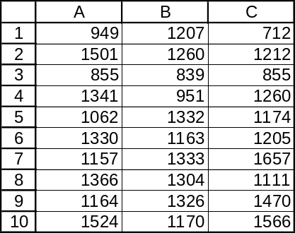

4.48 c/c/m Using Excel, the 30 values in the simple random sample are as shown below.
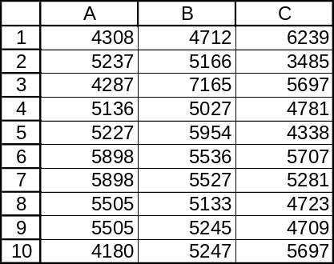

4.49 c/c/m Using Excel, the descriptive statistics for all 100 persons, along with descriptive statistics for
each of the two simple random samples with n = 20.
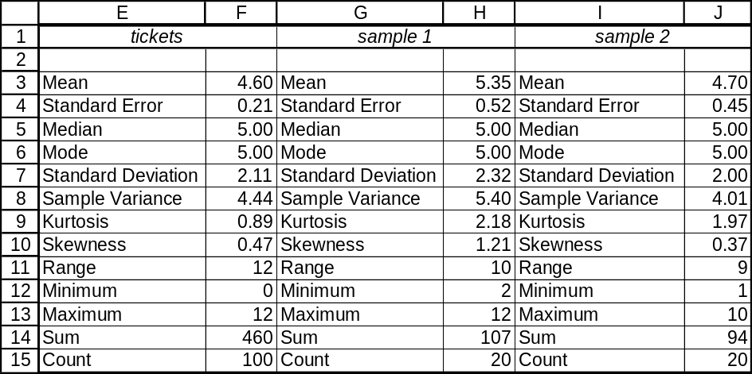
a. The mean of the first sample is 5.35 tickets.
b. The mean of the second sample is 4.70 tickets.
c. The values of the means are not identical. Because of unavoidable sampling error, it is not very likely that the mean of two such samples would be identical. The mean for sample 2 is closer to 4.60 tickets, the mean for the 100 persons from which the two samples were taken.

CHAPTER EXERCISES
4.50 d/p/m
a. Primary data, because they are generated by the researcher to study the problem at hand.
b. External secondary data, because they come from a source outside the firm and they were not generated for the purpose of examining the problem at hand.
c. Internal secondary data, because they come from within the firm and they were not generated for the purpose of examining the problem at hand.

4.51 d/p/e The union official is most concerned with representing the union the way the majority of members want it to be represented. Thus, an appropriate question for the researcher to answer is,
"Which of the three stances would you like to see the union take in the upcoming negotiations?"

4.52 d/p/m
a. This is probably a descriptive study.
b. This is most likely a causal study.
c. This would probably be an exploratory study.
d. This must be a predictive study.

4.53 d/p/m Sampling error can be traced to the decision to survey a sample of the companies rather than all 25. Response error occurs when companies exaggerate their ability to supply desired components on time and in the quantity desired. Finally, nonresponse error can be traced to the differences between the 8 companies who responded to the survey and the 7 who did not respond.

4.54 d/p/m
a. Nonresponse error could influence the results, as unsatisfied customers may be more likely to fill out the card. On the other hand, the card might appeal more to satisfied customers. In either case, there are likely to be differences between those who respond and those who do not respond.
b. The cards provide the added benefit of allowing customers to "speak out" about the
service they received. In addition, customers who do not fill out a card will feel like the
restaurant "cares" and is actively trying to do things to improve the services provided.

4.55 d/p/m A multiple choice question has several possible answers; a dichotomous question has two possible answers. An open-ended question will have no "set" responses. Some examples:
a. Multiple choice: On average, how often do you read The Wall Street Journal?
[ ] daily [ ] 3 to 4 times per week [ ] 1 to 2 times per week [ ] never
b. Dichotomous: Do you have your own subscription to The Wall Street Journal? [ ] Yes [ ] No
c. Open-ended: Which features do you consider to be most important in The Wall Street Journal?

4.56 d/p/m
a. The dependent variable is the number of visitors to the museum, and the independent variable is the hiring of Bert McGruff.
b. The season of the year likely affects the number of visitors to the museum; people are more likely to visit when they have time to visit and when the weather is conducive to leaving the house.
During May, many potential visitors were still in school. By June, this was no longer true.
c. Internal validity refers to the extent to which changes in the independent variable, in this case the hiring of Bert McGruff, are actually responsible for changes measured in the dependent variable, in this case the number of visitors to the museum. Given the other factors that might have affected the number of visitors, it is not clear that the increase can be traced to Bert alone. Therefore, it is not advisable to give Bert a raise solely because of the increased attendance.

4.57 d/p/m External validity refers to the extent to which the results of an experiment can be generalized to other settings. This experiment would probably have external validity for salespersons working in snowy regions; however, it is not clear that a snowmobile will be much of an incentive to someone living in Florida, Arizona, or other warm climates.

4.58 d/p/m Several behavioral and personal characteristics can be observed watching someone who does not know he is being watched. In this situation these might include responses to salespeople, styles of shopping, the length of time a man spends in a women's department and vice versa, and the length of time it takes to complete a sale. There are, of course, many others.

4.59 d/p/m
a. The Professional Bowlers Association is one such organization. Two others are the National Bowling Council and the Youth Bowling Council.
b. The Child Abuse Prevention Network and the National Clearinghouse on Child Abuse and Neglect Information are two sources of information on child abuse.
c. The National Safety Council and the Industrial Accident Prevention Association are two sources of information on industrial accidents.
d. The Antique Auto Club and the Horseless Carriage Club of America are two organizations with information about antique and classic cars. There are a lot of more specialized clubs, such as the Mercury Restorers Club of America and the Vintage Volkswagen Club of America.

4.60 d/p/m Radio Shack could use data warehousing and data mining to uncover patterns and relationships relevant to their retail stores, the movement of their products, the purchasing habits of occasional as well as frequent customers and, in general, to improve profits by improving their understanding of their business and their customers.

4.61 d/p/m There are many considerations in evaluating suitability of data in any study. Do the data cover a long enough time frame? Are they presented in the proper series (daily, weekly, monthly, etc.), or can they be modified to the proper timeliness without losing too much information? Were the data generated by someone who was hoping to "prove" a specific result?
If the data are not free, are the costs justified by the value of the data, and will they allow the project to stay within set budgetary constraints? Special skepticism should be reserved for data generated by unknown sources who have something to gain or lose based upon the findings of the study. In acquiring data, it is best to remember the Latin phrase "caveat emptor." (Let the buyer beware.)

4.62 d/p/m
a. Shirley can read online annual reports published by the companies, as well as annual reports from their competitors. By visiting Google.com, she can search for message boards, interest groups, blogs, discussions and other forms of communication that mention the company’s products and practices. Also, disgruntled customers and former employees often set up websites devoted to the company and the problems they have encountered with it. Googling to find out more about the backgrounds of executives and persons with whom she will be interviewing could be useful as well.
b. If Shirley has her own website, company personnel could visit and learn more about her. If Shirley has used her own name or e-mail address in making posts to message boards or interest groups, company personnel could Google her and gain information about her. They can even use GoogleEarth to get a satellite view of her home/apartment and neighborhood. Shirley should be careful in her blogging and Twittering, as well as being cautious and protecting her presence regarding sites like Facebook, MySpace, and YouTube. If Shirley has posted to some controversial message forums or has any type of web presence containing opinions, language, photos, or videos that might lead to company personnel (perhaps unfairly and incorrectly) perceiving her as a “troublemaker” or a poor fit, they may well choose to hire someone else.

4.63 p/c/m A portion of the Bureau of the Census page dealing with Kalamazoo County, Michigan.
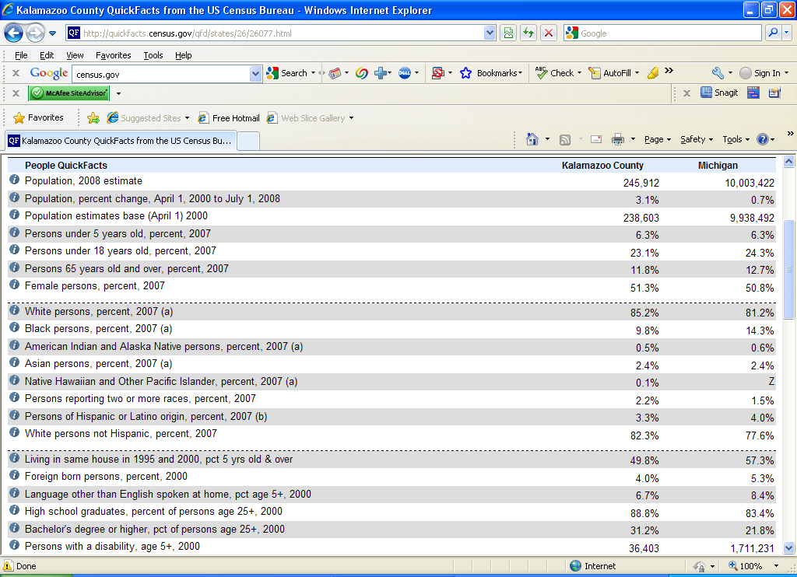

a. In Kalamazoo County, 88.8% of those 25 years or older are high school graduates.
b. As shown above, 11.8% of the 245,912 county residents are 65 or older.
c. In a lower portion of the page, not shown here, the median household income is reported as $44,324.

4.64 p/c/m The “Related Sites” section of the Bureau of the Census page leads to a large number of international statistical sources. One of them is Statistics Canada, at statcan.gc.ca. At this writing, they report the population of Canada as 33,592,686.

4.65 p/c/m Results will vary, of course. For listings in the telephone directory white pages, it is possible to obtain a great deal of information, including such things as exact location maps and the names and descriptions of nearby businesses.

4.66 p/c/m One of the sites where messages, opinions, and reviews are abundant is Epinions.com. At this writing, there were 127 reviews pertaining to the Sony Cyber-Shot DSC-H5 digital camera. A Sony design engineer, service manager, or marketing person could get a lot of useful information from lurking on sites such as these. For example, the design engineer could discover what things customers and potential customers like and don’t like about current Sony digital cameras compared to the competition. A service manager might discover problem areas such as specific service facilties or personnel with whom customers have had particularly negative experiences.

4.67 d/p/m Because many people who participate in these activities are not available between 6 P.M. and 9 P.M., the sample will be biased toward nonparticipants. For this reason, the sample will be neither random nor representative.

4.68 d/p/d
a. There will not be any sampling error present since a census of the entire student population is being taken instead of a sample.
b. There will probably be nonsampling errors present. The wording of the question may invite responses that are biased. Students may be afraid to admit they have shoplifted from the university bookstore.

4.69 c/a/m
a. Since 200(0.27) = 54.0, we should question 54 college graduates.
b. We should question 200 - 54 = 146 persons who are not college graduates.

4.70 d/p/m Purposive sampling is being used in this problem. The weightlifters are chosen because they are not typical of the population. If they can't break free after being restrained, the general population shouldn't be able to break free either.

4.71 d/p/m Quota sampling is being used. The population is divided up into layers, or "strata", then the members of the various strata are chosen using a nonprobability sampling technique.

4.72 d/p/d This is not a probability sample, since the persons have been arbitrarily selected from the
departments. This is a quota sample.

4.73 p/c/m As shown below, the mean of the simple random sample of 30 employees was 42.60 hours, somewhat greater than the national average of 38.9 hours. It seems possible that the 300 Acme Eyebolt workers might be putting in a longer workweek than their production counterparts nationwide.
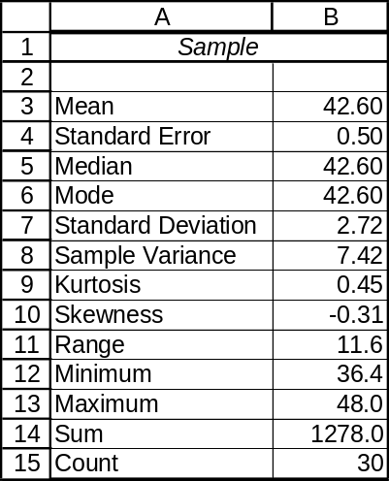

4.74 p/c/m As shown below, the mean of the simple random sample of 20 bolts was 10,120.05 pounds per square inch. Although the sample mean would seem to be comfortably above the 10,000 psi level claimed by the manufacturer for the population of bolts, we would have to carry out a hypothesis test to help us reach a more informed conclusion. These kinds of tests are discussed in Chapter 10.
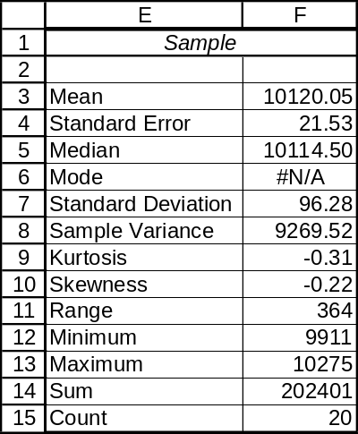

INTEGRATED CASES

THORNDIKE SPORTS EQUIPMENT (THORNDIKE VIDEO UNIT TWO)

1. U.S. sports equipment sales in 2008 were about $24.9 billion. Exercise equipment ($5.3 billion)
was the largest segment, followed by firearms/hunting equipment ($4.6 billion) and golf equipment ($3.5 billion). [via links through nsga.org, the National Sporting Goods Association]

2. According to the National Sporting Goods Association (via nsga.org), consumers spent $32.6 million on racquetball equipment during 2008. Among the leading manufacturers of tennis racquets and equipment are Head USA and Wilson Racquet Sports. Among the leading manufacturers of racquetball racquets and equipment are E-Force, Ektelon, Head, Pro Kennex, and Wilson. [via links through usra.org, the United States Racquetball Association, and racquetworld]

3. The companies listed above maintain websites, but the content of these sites is largely product information and promotional materials, and financial information about the individual companies is not readily available. Some industry information is available or can be accessed from links at various websites like those described above.

4. A leading manufacturer of racquetball racquets is Ektelon. Google.com searched for 0.21 seconds and came up with 132,000 listings containing the word “Ektelon.” A more limited search for posts containing both “Ektelon” and “excellent” required 0.21 seconds and turned up 9880 listings.

